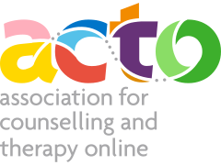
‘MORE ABOUT YOUR THERAPIST’ SECTION TEMPLATE

Reminder: this is only to be completed by Professional and Senior Professional Members.
You may wish to use this as a template and complete and save, before copying and pasting into your online profile. This way, if you lose any data or forget to ‘update profile’ you won’t have lost all you have written. Just copy and paste it back in.

MORE ABOUT YOUR THERAPIST
Online formats used
(video/audio/live chat/email)
About me
(short overview/description which will show in the member list – max 75 words)
More about me
(This is a more detailed description which will be visible on your directory profile page - max 500 words)
I specialise in
(your specialities such as depression, PTSD – max 6 conditions)
My Approach
(max 500 words)
Clients I work with
(e.g., Adults/CYP – max 50 words)
Languages used
(max 30 words)
Website details
My fees
(describe how you charge for your services – max 50 words)
Email address
(visible for clients)
Contact number
(visible for clients)

